1. 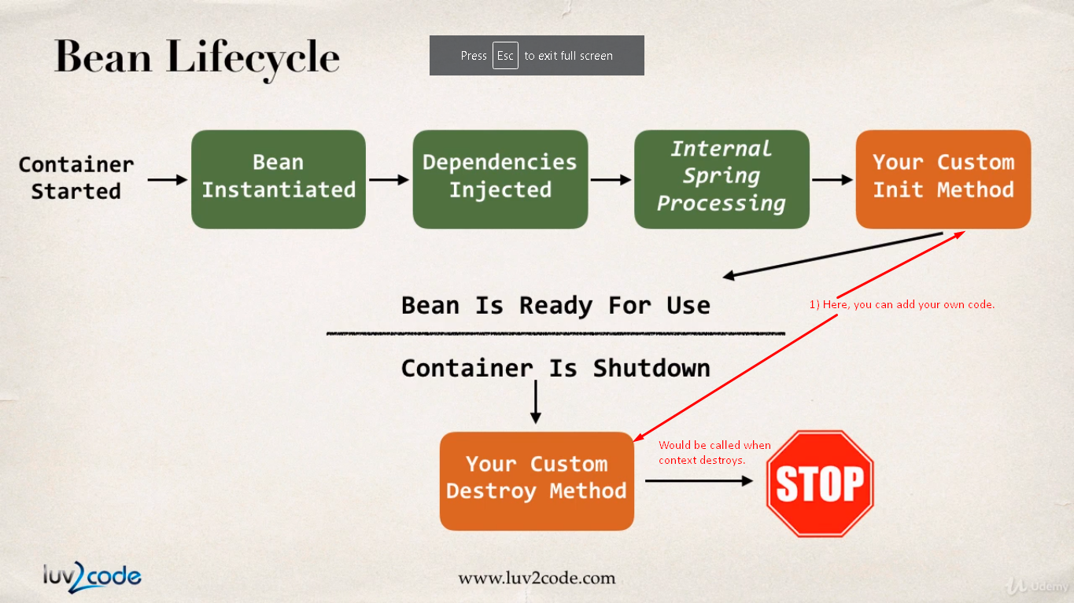
2. “**Internal Spring Processing**”: This processing occurs with bean factory.
3. “**Your Custom Init Method**”: You’ve the option of adding your own custom initialization code.
4. 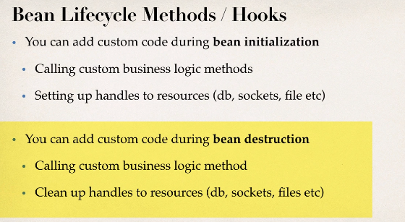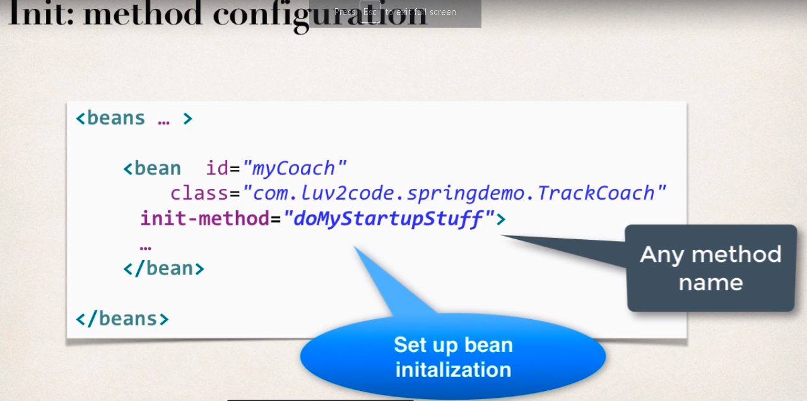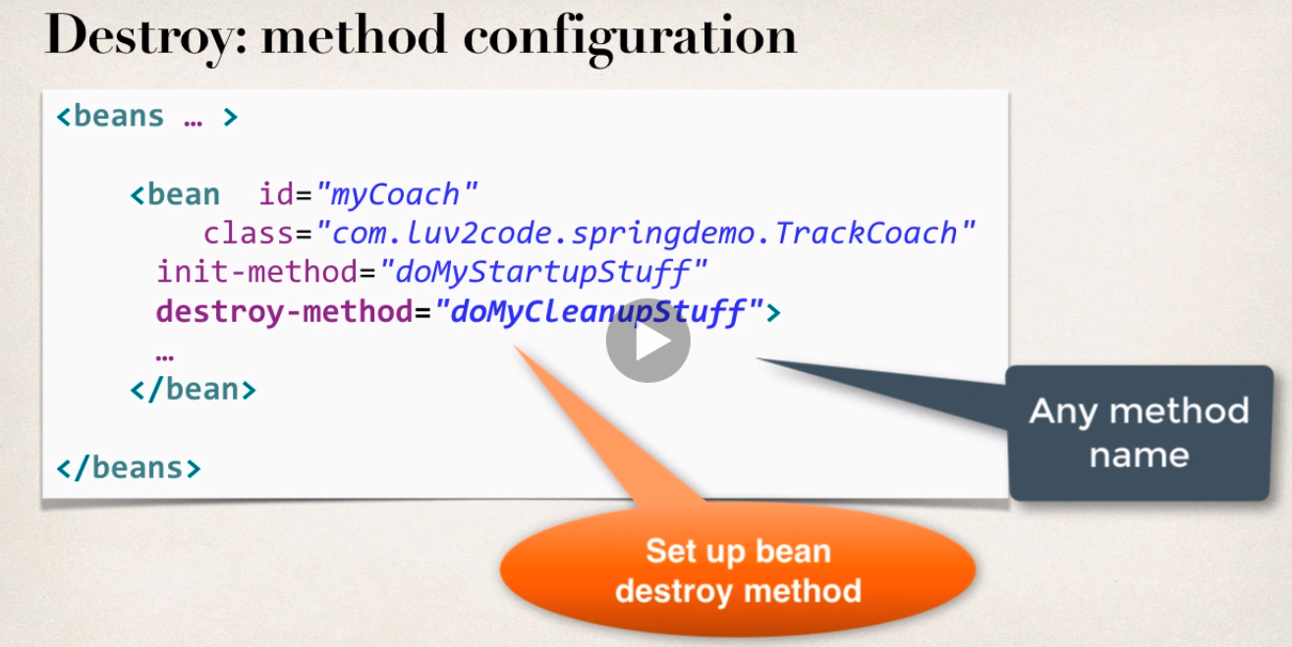
5. 